Experiment 5 M. Devarajulu
Aim 192212058
To solve missionaries cannibal problem using python program
Algorithm
1 Start the program.
2 Represent each state as (Missionaries Left, Cannibals Left, Boat Side).
3 Initialize the start state as (3, 3, 0) and the goal state as (0, 0, 1).
4 Use Breadth-First Search (BFS) to explore all possible valid states.
5 Generate the possible boat moves:
- 1 Missionary
- 2 Missionaries
- 1 Cannibal
- 2 Cannibals
- 1 Missionary and 1 Cannibal
6 Check whether each new state is valid:
- Missionaries should never be outnumbered by cannibals on either bank (unless no missionaries are present).
7 Continue searching until the goal state is reached.
8 Display the sequence of states representing the solution.
9 End the program.
Program
from collections import deque

# Check whether a state is valid
def is_valid(m_left, c_left, m_right, c_right):
if m_left < 0 or c_left < 0 or m_right < 0 or c_right < 0:
return False

if m_left > 0 and c_left > m_left:
return False

if m_right > 0 and c_right > m_right:
return False

return True

# BFS function
def missionaries_cannibals():
start = (3, 3, 0) # (Missionaries Left, Cannibals Left, Boat Side)
goal = (0, 0, 1)

queue = deque([(start, [])])
visited = set()

while queue:
(m_left, c_left, boat), path = queue.popleft()

if (m_left, c_left, boat) in visited:
continue
visited.add((m_left, c_left, boat))
path = path + [(m_left, c_left, boat)]

if (m_left, c_left, boat) == goal:
print("Solution Found!")
for state in path:
print(state)
return
# Possible boat movements
moves = [
(1, 0),
(2, 0),
(0, 1),
(0, 2),
(1, 1)
]
for m, c in moves:
if boat == 0:
# Boat moves Left -> Right
new_state = (m_left - m, c_left - c, 1)
else:
# Boat moves Right -> Left
new_state = (m_left + m, c_left + c, 0)
nm_left, nc_left, nb = new_state

nm_right = 3 - nm_left
nc_right = 3 - nc_left

if is_valid(nm_left, nc_left, nm_right, nc_right):
queue.append((new_state, path))
print("No Solution Found!")

# Run the program
missionaries_cannibals()

Output:

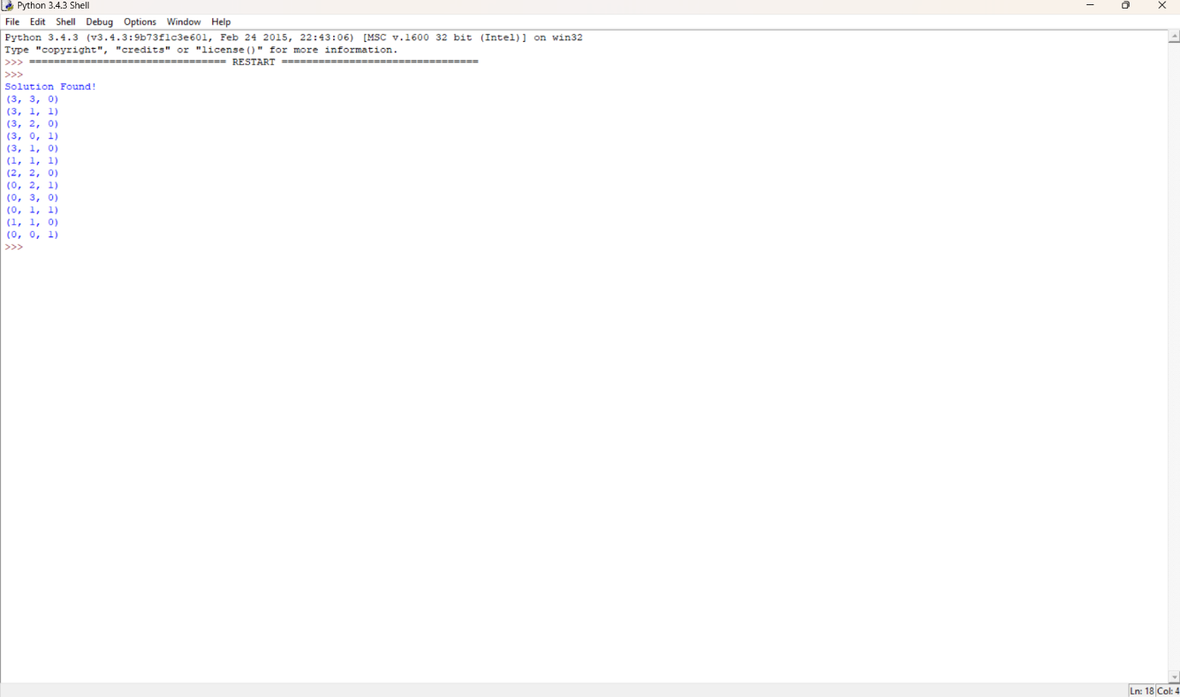

Result:
The program uses the Breadth-First Search (BFS) algorithm to find a valid sequence of moves. The final state:

